Test Case: tc001_SPX_Dev5_Crear_Requisicion_Spot_Tipo_Cobro_CC
Step 1 - Enter username and password and click to button Enter : Credentials Entered
Image file-name: QC_Testing-tc001_SPX_Dev5_Crear_Requisicion_Spot_Tipo_Cobro_CC-1783980368161

Step 2 - Select to UEN and Access to Spot Buy Requisitions : UEN Correctly selected and Correct access
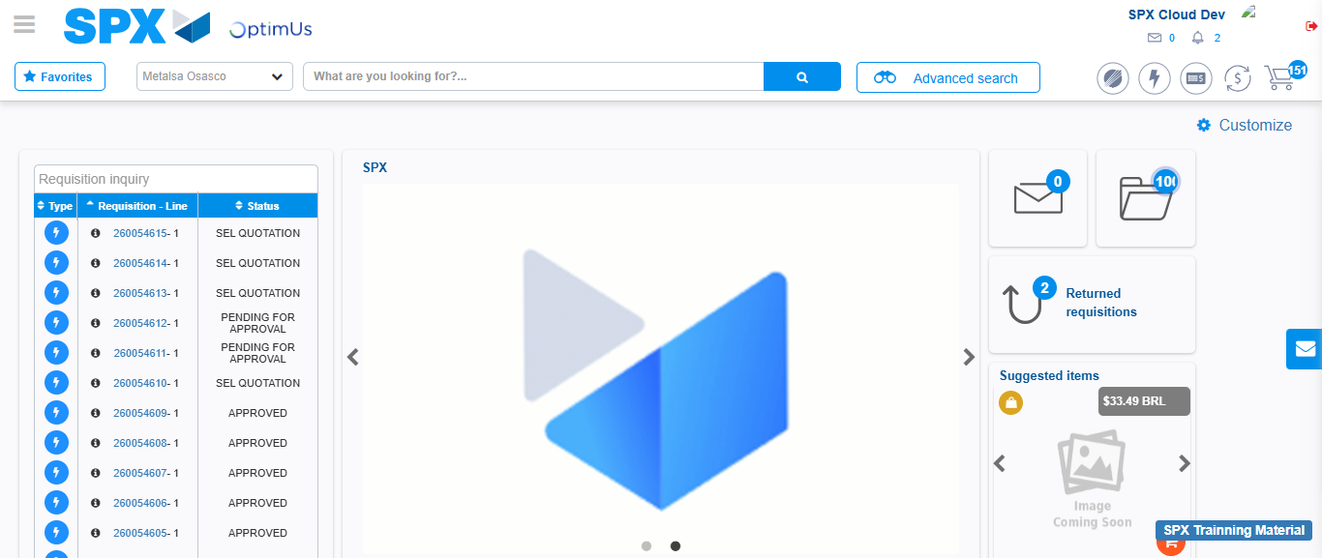Image file-name: QC_Testing-tc001_SPX_Dev5_Crear_Requisicion_Spot_Tipo_Cobro_CC-1783980435677

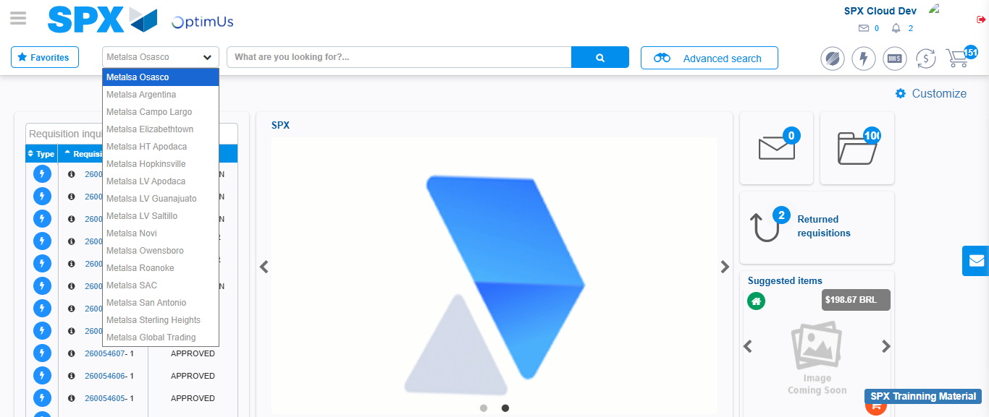Image file-name: QC_Testing-tc001_SPX_Dev5_Crear_Requisicion_Spot_Tipo_Cobro_CC-1783980438265

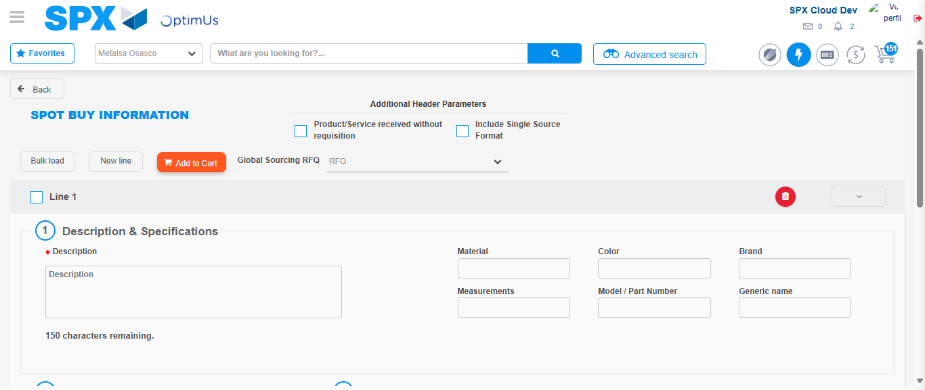Image file-name: QC_Testing-tc001_SPX_Dev5_Crear_Requisicion_Spot_Tipo_Cobro_CC-1783980447625

Step 3 - Data Capture Spot Buy Requisition : Data captured correctly
Image file-name: QC_Testing-tc001_SPX_Dev5_Crear_Requisicion_Spot_Tipo_Cobro_CC-1783980447862

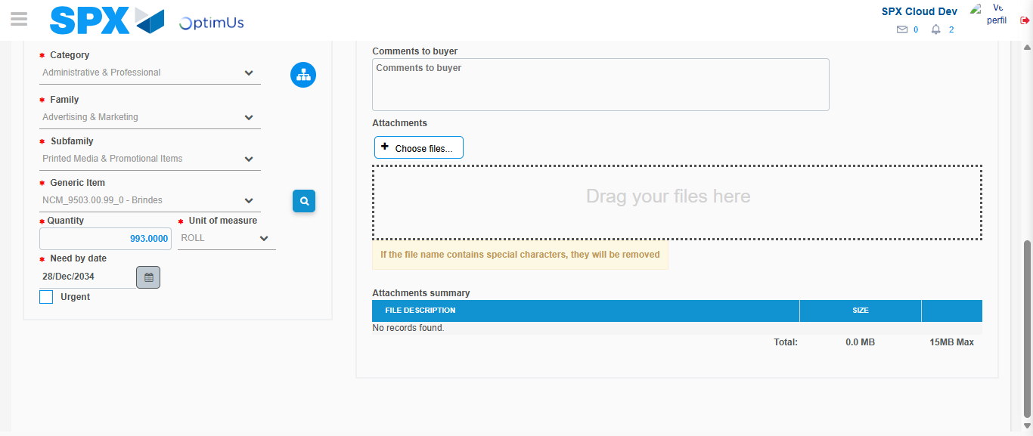Image file-name: QC_Testing-tc001_SPX_Dev5_Crear_Requisicion_Spot_Tipo_Cobro_CC-1783980459766

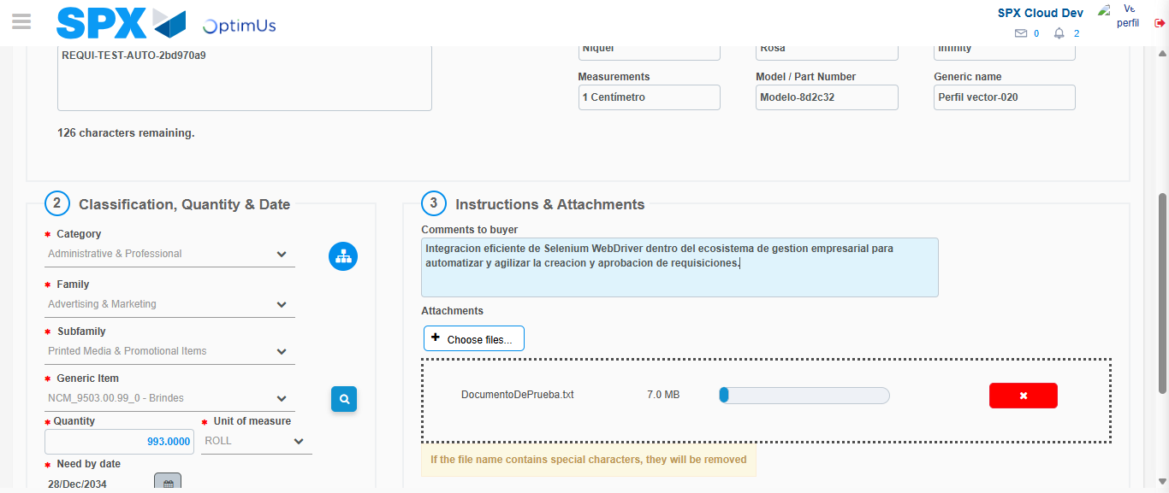Image file-name: QC_Testing-tc001_SPX_Dev5_Crear_Requisicion_Spot_Tipo_Cobro_CC-1783980460529

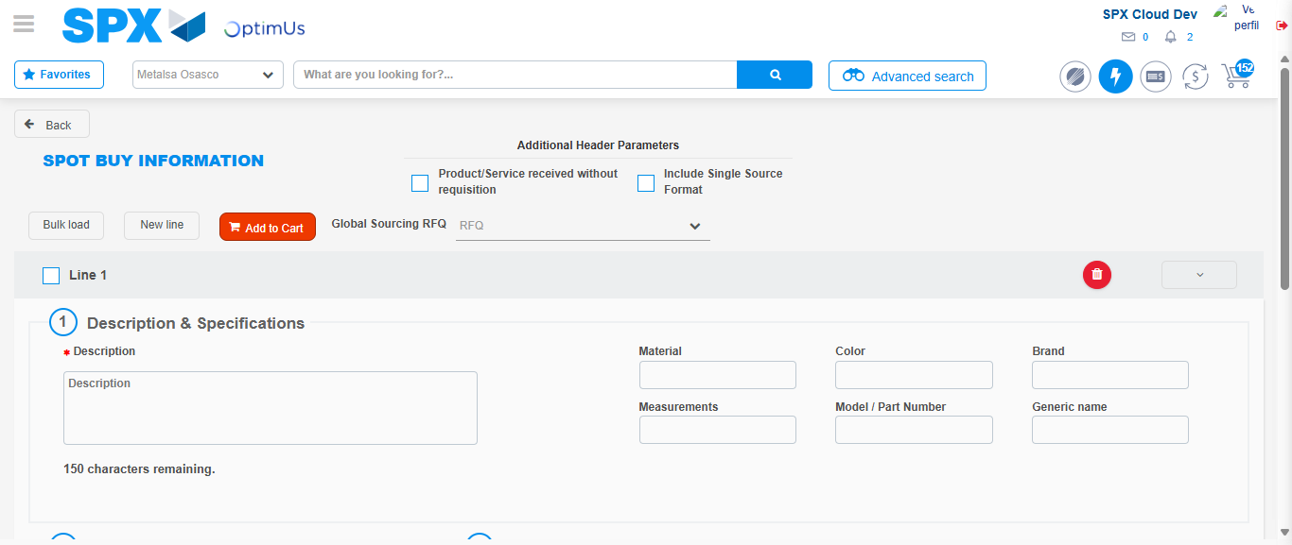Image file-name: QC_Testing-tc001_SPX_Dev5_Crear_Requisicion_Spot_Tipo_Cobro_CC-1783980466888

Step 7 - Return to Main Page SPX : Return to Main Page SPX
Image file-name: QC_Testing-tc001_SPX_Dev5_Crear_Requisicion_Spot_Tipo_Cobro_CC-1783980435677

Image file-name: QC_Testing-tc001_SPX_Dev5_Crear_Requisicion_Spot_Tipo_Cobro_CC-1783980438265

Image file-name: QC_Testing-tc001_SPX_Dev5_Crear_Requisicion_Spot_Tipo_Cobro_CC-1783980447625

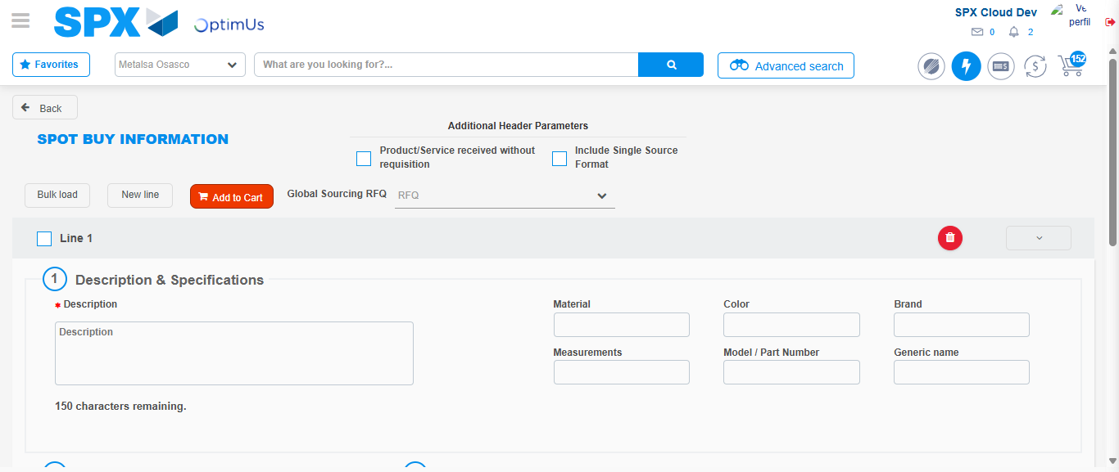Image file-name: QC_Testing-tc001_SPX_Dev5_Crear_Requisicion_Spot_Tipo_Cobro_CC-1783980469123

Image file-name: QC_Testing-tc001_SPX_Dev5_Crear_Requisicion_Spot_Tipo_Cobro_CC-1783980469304

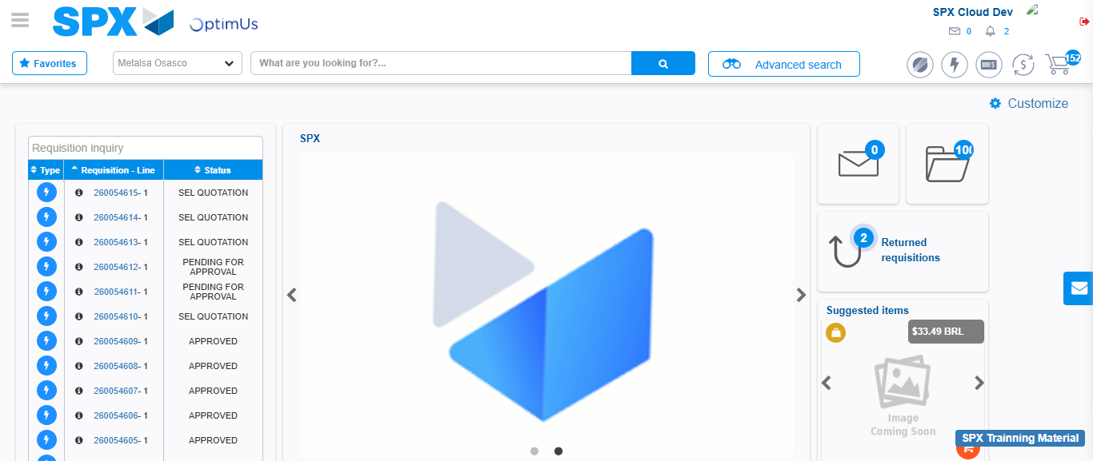Image file-name: QC_Testing-tc001_SPX_Dev5_Crear_Requisicion_Spot_Tipo_Cobro_CC-1783980490323

Step 8 - Log Out : Log Out SPX
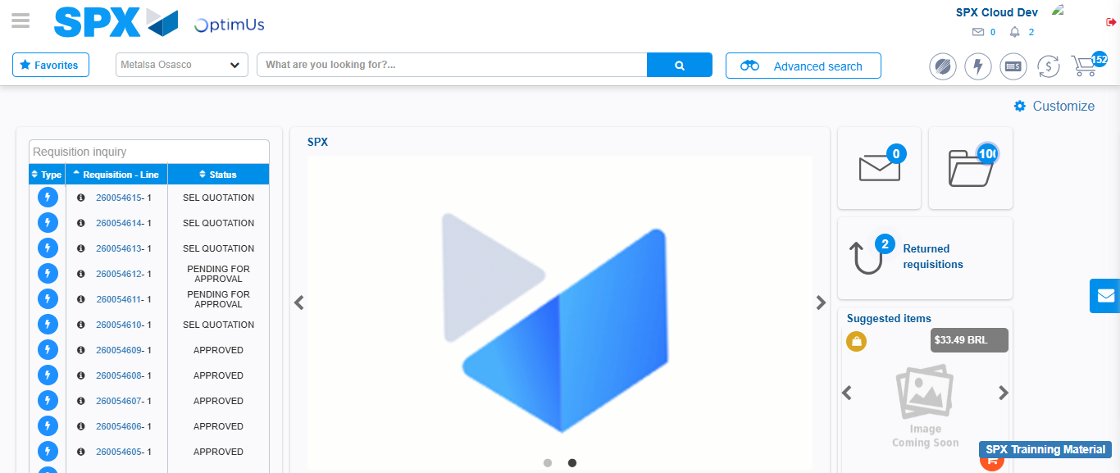Image file-name: QC_Testing-tc001_SPX_Dev5_Crear_Requisicion_Spot_Tipo_Cobro_CC-1783980490615

